SUGAR COSMETIC WEBSITE
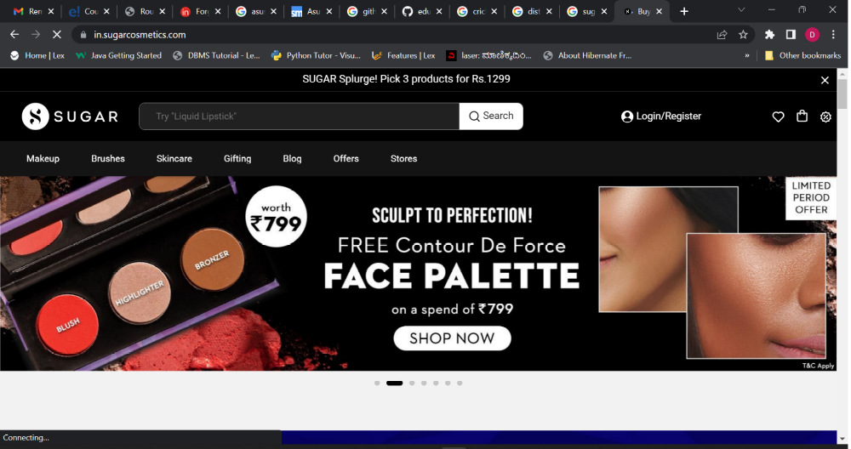
It is an e-commerce website, in this website the users/customers buy cosmetics.
Page Structure:
- HOME PAGE:
Navigation bar-
Logo + Brand name(hyper linked-https://in.sugarcosmetics.com/)
Search bar
Login/register
ICONS-
Wishlist
Cart, Offers

Menu Bar-
A horizontal division below navigation bar where different categories of items are available to see.
(Makeup, Brushes, Skincare, Gifting, Blog, Offers, Stores)

Features:
Sliders with arrows and indicators - (Images)
Deals - (Images)
Featured - (Images, Videos)

2.Login/Register
Login/Sign Up Using Phone Number.
3.Details of the product:
Image of the product,
Details of the product(description)
Recommended products(suggestions),
Add to cart.(button)
Floating icon of cart.(RHS)
4.Viewcart page:
List of the products added – cart summary and price details
5.Checkout page:
Details of the user-Guest user
6.Payment page:
With different payment methods and price details.

7.Footer-
Stores, Terms and conditions, Returns, FAQ’s, About us.

